Use-Case Realization Report
View Lesson

Issue <1.0>
Revision History
Date | Issue | Description | Author
12/10/09 | 1.0 | Initial Version | Rajendran Kumaraguru

Table of Contents
1. Brief Description 4
2. Flow of Events 4
2.1 Standard Flow 4
2.2 Exception Flow 4
3. Interaction Diagrams 4
3.1 Collaboration Diagram for View Lesson 4
4. Participating Objects 4
5. Class Diagrams 5
5.1 Class Diagram for View Lesson 5
6. Derived Requirements 5

Use-Case Realization Report
View Lesson

Brief Description
Portal admin will be able to view the lessons which are already created. Portal admin will have the necessary privileges in order to update the lesson.

Flow of Events

Standard Flow
- Portal Admin login in to the system.
- Click the btnClickViewSite.
- Loading the site details.
- Get all site details
- Validate fields will be validating the data while view the lesson.
- Portal admin will be able to view the site.

Exception Flow
  - When there is no particular lesson is not available then there should be an exception will throw lesson doesn’t exist.
  - If there is any error while performing the validate fields then exception will be thrown to portal admin.

Interaction Diagrams

Collaboration Diagram for View Lesson
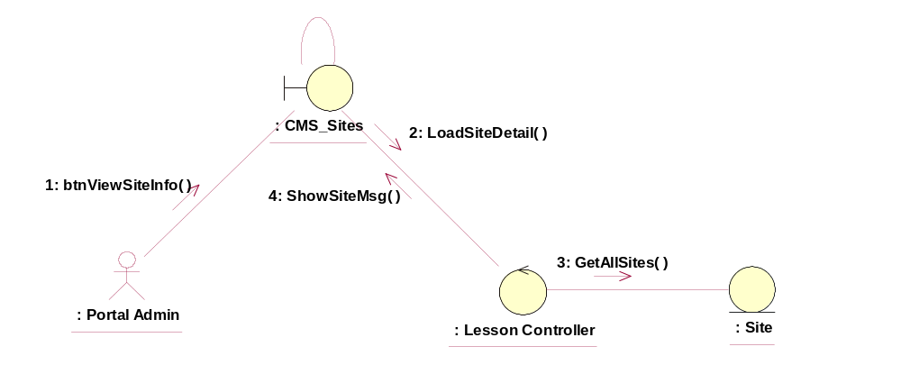

Participating Objects
: : CMS_Sites
This entity is the lesson object, it belongs to JMD.
:: Lesson Controller
This is the controller to upload, add, delete and modify lessons.
: Site
Adding the site upon creation of the folder.

Class Diagrams

Class Diagram for View Lesson
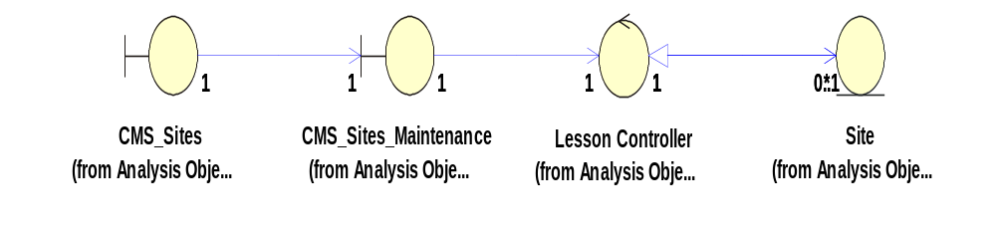

Derived Requirements
[enter the derived requirements here]

